DAKSH DECA DAY 1 SCHEDULE

\*Inauguration at 9:00 am

\*Inauguration and Powertalks will be held at Chanakya Vihar

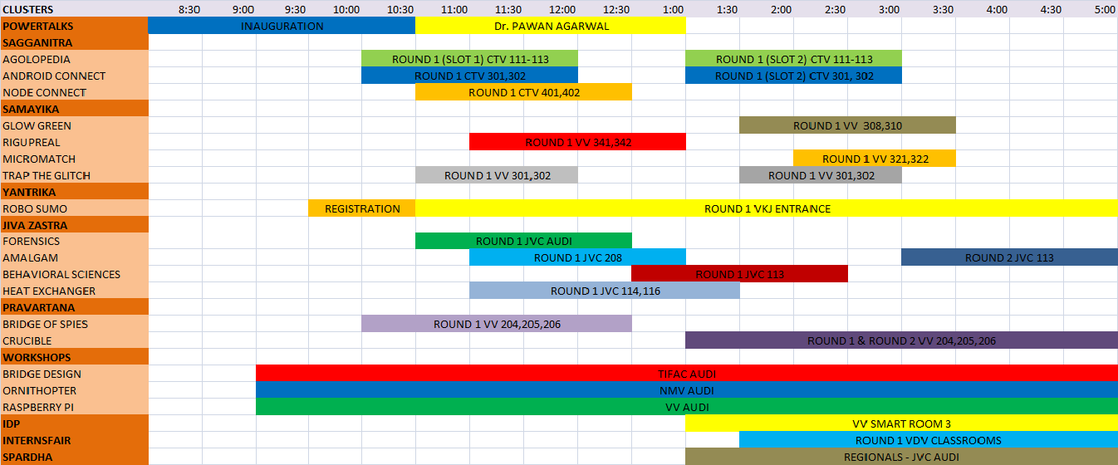

\*Bike Stunt Show at 5:00pm

DAKSH DECA DAY 2 SCHEDULE

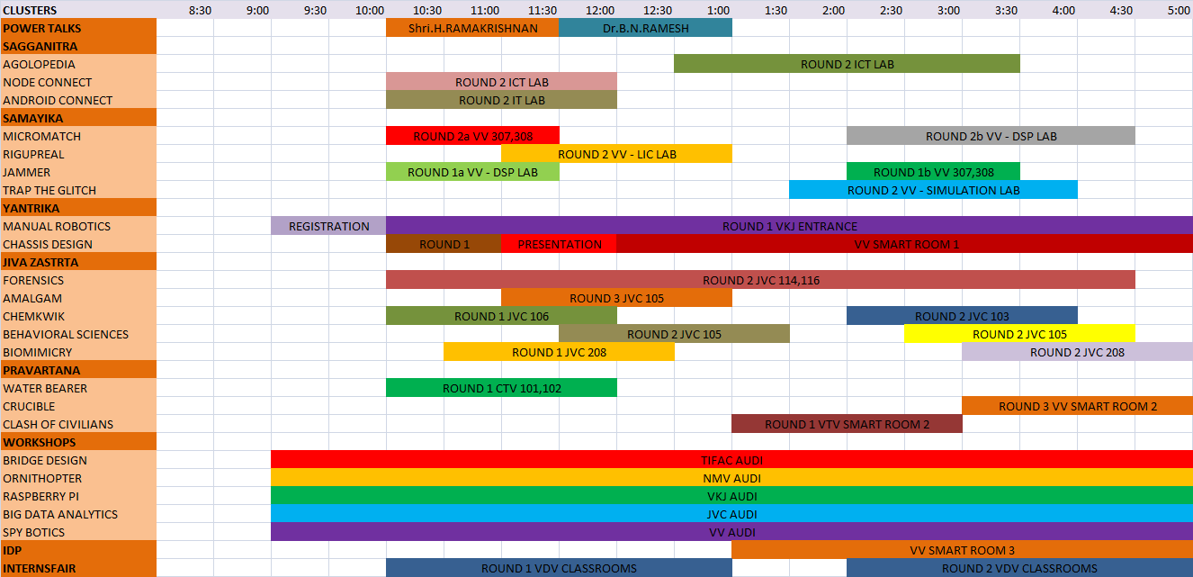

\*Shows start at 5:45pm

DAKSH DECA DAY 3 SCHEDULE

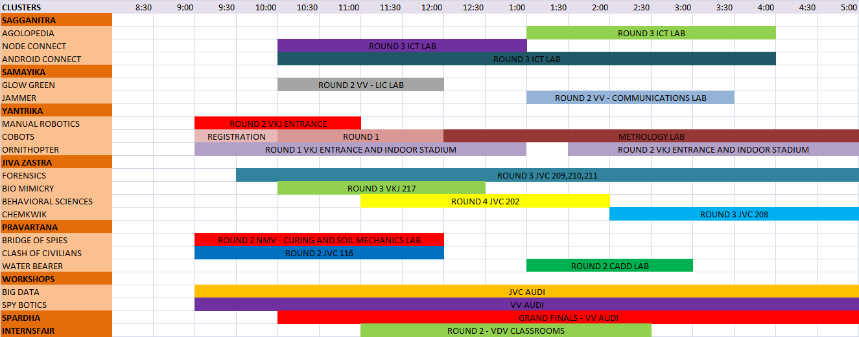

\*Shows start at 6:00pm